**PART B**

**AIM OF THE PROJECT:** Create Bus topology in Cisco Packet Tracer.

**BRIEF DESCRIPTION:**

* Bus topology is a network setup where each computer and network device are connected through a single cable or backbone. It is also known as Line topology.
* These computers connected in the network share resources such as files, network access, printers, etc.
* Depending on the type of computer network card, a coaxial cable or an RJ-45 network cable is used to connect them together. If this cable is damaged then the connection of all the computers will be lost.
* When Bus Topology has only two endpoints, it is known as Linear Topology. In Bus topology data is transmitted only in one direction.
* Bus topology carries transmitted data through cable. When the data reaches each node, node checks destination address (MAC/IP address) to work out if it matches their address.
* If address does not match with node, the node discards the packet. But if addresses of node match to address contained within data then the packet is decapsulated and data present in it is send for further processing.

**AIM OF MICRO PROJECT:**

The micro-project aims to: -

* Study about the features and components present in cisco packet tracer and implement them.
* Study the structure of bus topology.
* Study functioning of bus topology.
* Study how data packets travel in bus topology.

**COURSE OUTCOME INTEGRATED:**

* Design Computer Networks using appropriate Network Topologies.

.

**ACTUAL PROCEDURE FOLLOWED:**

1. **GROUP FORMATION: -**Acn Is A Subject That Provides Us Knowledge About Advance Protocols of Modern Network. It Gives Us Idea About the Principals and Architecture of Modern Network. It Teaches Us to Configure Various Tcp /Ip Protocol at Different Layers. The Basic Aim of Micro- Project Is to Accelerate the Attainment of The Various Outcome in The Course. In the First 2 Weeks of December The Subject Was Introduced. The Syllabus as Well as Detail of Micro-Project Was Discussed. A Group Of 10 Members Was Formed and The Group Leaders Were Selected. The Schedules of Plan “A”,” B” & “Presentation” Were Finalized. The Various Micro-Project Topics Related to Subject Were Discussed Our Guide Gave Us the Opportunity to Select the Topic of Our Choice.
2. **FINALIZATION OF MICRO-PROJECT: -** After Attending the Lectures For 2 Weeks. We Selected the Topic for Micro-Project. We Discussed About the Topic with Our Guide Regarding the Concept Which We Were Going to Apply in The Project. We Individually Tried to Explain the Basic Platform of Project.
3. **PLANNING: -** After Finalization of The Project We Started Working on the project. We Started the Planning Phase. We Discussed Among Ourselves Regarding the Resources Required to complete the project In This Week We Completed ‘Part A Plan’ Of the Micro-Project Which Is Nothing but An Initial Description About The project. We Submitted It to The Guide.
4. **MODULE DISTRIBUTION &ANALYSIS PART: -** Once the Planning Was Over Regarding Resources, Etc. We Distributed the Different Module Among Us. We Also Started the Analysis of Project.
5. **IMPLEMENTATION: -** In the Week We Actually Started the Technical Phase. In This Phase We Technically Started Making the Circuit on Cisco Packet Tracer. Each and Every Student Helped in Making and Testing the Circuit. Finally, The Project Was Within the Schedule Time.
6. **PRESENTATION: -** In This Week We Presented the Micro-Project in Front of The Guide. The Whole Group Presented the Project with Confidence. She Asked Us Various Queries Regarding the Functioning of Project. We Presented Detail About Each and Every Function of Project. She Asked Us to Do Various Changes
7. **SUBMISSION: -** This Week Was Submission Week. We Submitted Our Project Along With ‘Part A & B Plan’ To the Guide. We Also Submitted the Working Circuit and Soft Copies of Part A & Part B to The Guide

**Resources Used: -**

|  |  |  |  |  |
| --- | --- | --- | --- | --- |
| **Sr No** | **Name of Resources Required** | **Specification** | **Quantity** | **Remarks** |
| 1 | Computer | **Processor-**Amd  **Hard Disk-**2 Tb  **Ram-**16gb  **Operating System-**Windows 10 Pro | 1  1  1  1 | Hardware Used |
| 2 | Cisco Packet Tracer | Version 7.2 | 1 | Software Used |
| 3 | Components | PC, Switch, Copper Straight & Copper Cross Over Cable | 5 Pcs, 5 Switches & Cables as per Need | Components Used in Cisco to Create Project |

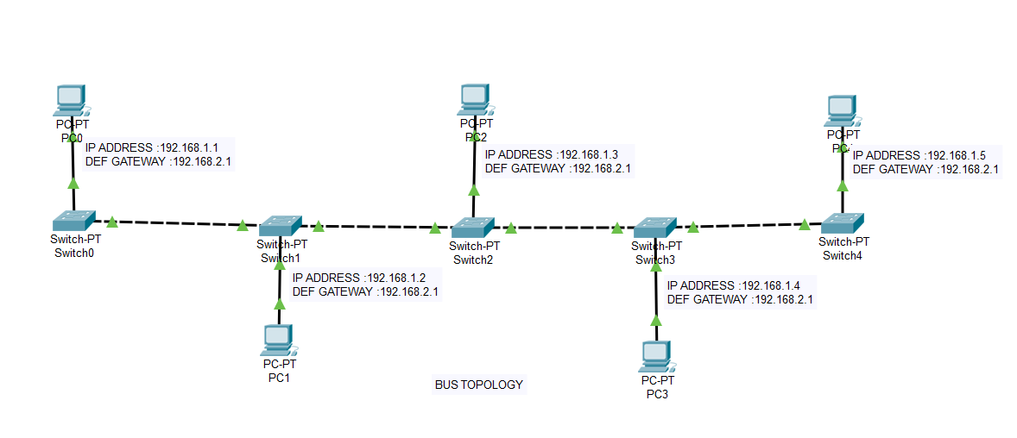**OUTPUT OF MICRO-PROJECT:**

* **CONFIGURATION:**

1. **Pc 0:**
2. **IP Address:** 192.168.1.1
3. **Default Gateway:** 192.168.2.1
4. **Pc 1:**
5. **IP Address:** 192.168.1.2

**NOTE:**

1. Make Connection as per Diagram.
2. Use the Cables as shown above.
3. No need to configure switch.
4. **Default Gateway:** 192.168.2.1
5. **Pc 2:**
6. **IP Address:** 192.168.1.3
7. **Default Gateway:** 192.168.2.1
8. **Pc 3:**
9. **IP Address:** 192.168.1.4
10. **Default Gateway:**  192.168.2.1
11. **Pc 4:**
12. **IP Address:** 192.168.1.5
13. **Default Gateway:** 192.168.2.1

**REFERENCES**

We Do Have Used A Few References During the Process of Building Our Project. The References Used Are from Websites, Books Etc.

The References Used Are:

1. **WEBSITES:**

1: www.tutorialspoint.com

2: www.packettracernetwork.com

3: study-ccna.com

1. **REFERENCE BOOKS**:

1: Advance Computer Network

2: Computer Network 4th Edition

**SKILL DEVELOPED/LEARNING OUT OF THIS MICRO PROJECT:**

* We Have Developed the Skill to Work as A Group, Share Data and Have Active Discussion.
* We Learnt About the Functioning & Architecture of Bus Topology.